Topalian
Python
Text File
Journal
by
Christopher Andrew Topalian

All Rights Reserved
Copyright 2000-2024
Dedicated
to
God the Father

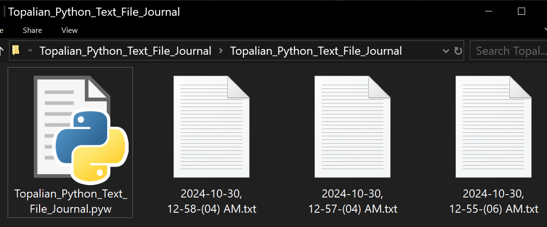
We double click the Topalian_Python_Text_File_Journal.pyw file
to create a journal entry, which consists of a
txt file with date, time in 12 and 24 hour format, and a calendar of that month.

Everytime that we double click the python file, it will create a new txt file Journal Entry.

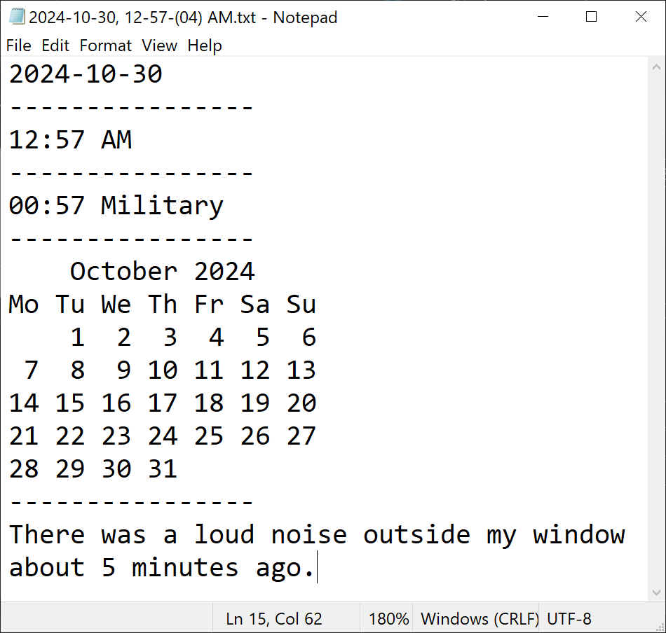
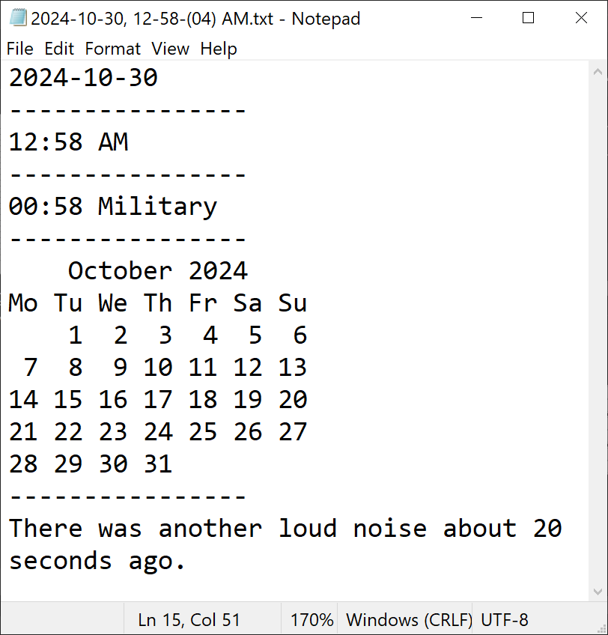
# Topalian_Python_Text_File_Journal.pyw

from datetime import datetime
import calendar
import os

def makeCalendar(year, month):
# create a text calendar
# with Monday as first day of week
cal = calendar.TextCalendar(calendar.MONDAY)

# format specified month as text
calendarText = cal.formatmonth(year, month)

return calendarText

####

def makeFileWithData():
# get current date and time
now = datetime.now()

# format date YYYY-MM-DD (2024-10-27)
dateString = now.strftime("%Y-%m-%d")

# format time AM/PM (02:30 PM)
timeAmPm = now.strftime("%I:%M %p")

# format time military (14:30)
timeMilitary = now.strftime("%H:%M")

timeForTxtName = now.strftime("%I-%M-(%S) %p")
nameOfFile = dateString + ', ' + timeForTxtName

# open main output file
with open(nameOfFile + ".txt", "w") as file:
# write date, time, and calendar information to file
file.write(dateString + "\n")
file.write("----------------\n")
file.write(timeAmPm + "\n")
file.write("----------------\n")
file.write(timeMilitary + " Military\n")
file.write("----------------\n")
file.write(makeCalendar(now.year, now.month))
file.write("----------------")

####

makeFileWithData()

####

'''
2024-10-27
----------------
02:02 PM
----------------
14:02 Military
----------------
October 2024
Mo Tu We Th Fr Sa Su
1 2 3 4 5 6
7 8 9 10 11 12 13
14 15 16 17 18 19 20
21 22 23 24 25 26 27
28 29 30 31
----------------
'''

# Dedicated to God the Father
# All Rights Reserved Christopher Andrew Topalian Copyright 2000-2024
# Topalian_Python_Text_File_Journal.pyw
# Version 001 - (2024-10-30)
# https://github.com/ChristopherTopalian
# https://github.com/ChristopherAndrewTopalian
# https://sites.google.com/view/CollegeOfScripting

What if we want to Save our Journal Entries in a Specific Folder?

We can make a folder named text,
and save our text files to this folder.
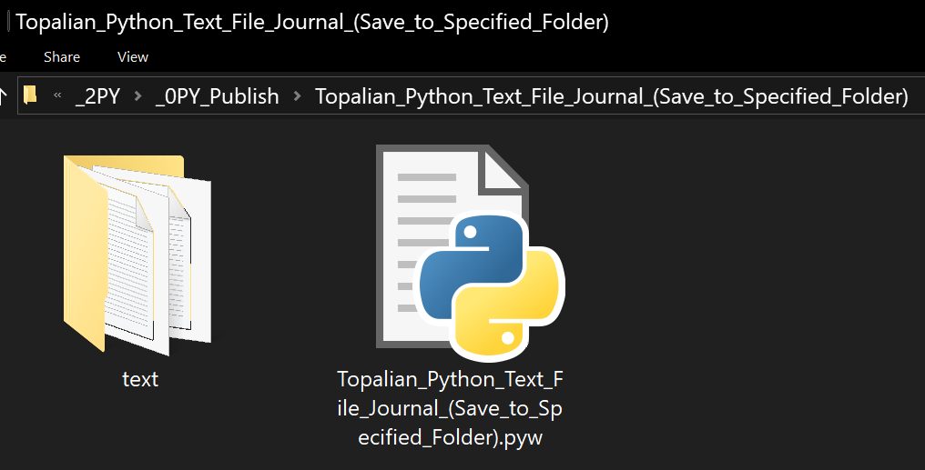

# Topalian_Python_Text_File_Journal_(Save_to_Specified_Folder).pyw

from datetime import datetime
import calendar
import os

def makeCalendar(year, month):
# create a text calendar
# with Monday as first day of week
cal = calendar.TextCalendar(calendar.MONDAY)
# format specified month as text
return cal.formatmonth(year, month)

####

def makeFileWithData():
# get current date and time
now = datetime.now()

# format date and time strings
dateString = now.strftime("%Y-%m-%d")
timeAmPm = now.strftime("%I:%M %p")
timeMilitary = now.strftime("%H:%M")
timeForTxtName = now.strftime("%I-%M-(%S) %p")
nameOfFile = dateString + ', ' + timeForTxtName

# create path to text folder
textFolder = os.path.join(os.path.dirname(__file__), 'text')

# make sure that text folder exists
os.makedirs(textFolder, exist_ok = True)

# define full path for file inside text folder
filePath = os.path.join(textFolder, nameOfFile + ".txt")

# open main output file
with open(filePath, "w") as file:
# write date, time, and calendar information to file
file.write(dateString + "\n")
file.write("----------------\n")
file.write(timeAmPm + " Am/Pm\n")
file.write("----------------\n")
file.write(timeMilitary + " Military\n")
file.write("----------------\n")
file.write(makeCalendar(now.year, now.month))
file.write("----------------")

####

makeFileWithData()

####

'''
2024-10-27
----------------
02:02 PM
----------------
14:02 Military
----------------
October 2024
Mo Tu We Th Fr Sa Su
1 2 3 4 5 6
7 8 9 10 11 12 13
14 15 16 17 18 19 20
21 22 23 24 25 26 27
28 29 30 31
----------------
'''

# Dedicated to God the Father
# All Rights Reserved Christopher Andrew Topalian Copyright 2000-2024
# Topalian_Python_Text_File_Journal_(Save_to_Specified_Folder).pyw
# Version 001 - (2024-10-30)
# https://github.com/ChristopherTopalian
# https://github.com/ChristopherAndrewTopalian
# https://sites.google.com/view/CollegeOfScripting

How to Combine
.txt files
into one
main.txt file
using
Command
Prompt

Version for when we have only ONE folder of .txt files that we want to combine.

// HowToCombineTextFilesOneFolder.js

First, we add two new lines at the end of every text file. This way they will later combine nicely with a line break in between each text file.

We open our folder of text files in command prompt by typing cmd in the adddress bar of the folder of text files.

cmd
press Enter

This opens our folder in the Command prompt.

We type in the words
copy *.txt main.txt
press Enter

This creates a new file that is named main.txt
This new file contains all .txt files in ONE file.
The original files are kept the same.
The original files are not changed by the process.
After we activate our script and make our main.txt file, we notice that there is a junk character at the end of the main.txt script that we have to delete.

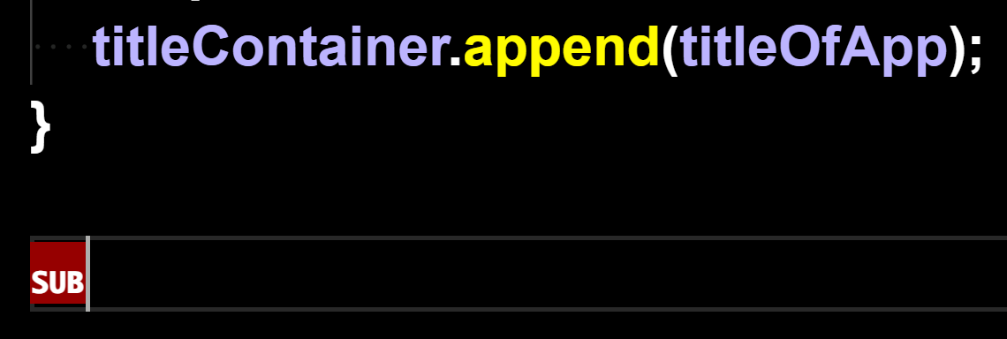
In VSCode the character might be called SUB
We remove this junk SUB character and the code will now run.
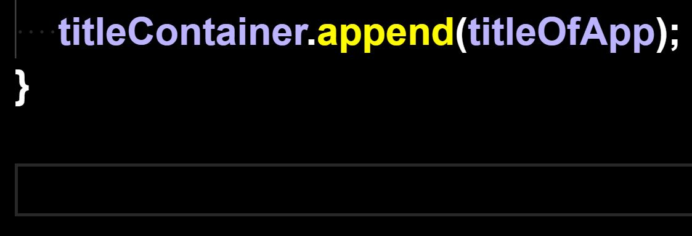
As we can see, the junk character is removed.

How to Combine
.txt files
into one
main.txt file
using
Command
Prompt

Version for when we have txt scripts in subfolders in our txt project folder, that we want to combine.
// HowToCombineTxtFilesMultipleFolders.js
TUTORIAL:
How to Combine all .txt files in all folders that are in our folder.

Getting things ready:
We should add two new lines at the end every text file. This way they will combine nicely with a line break in between each text filie.

Step One: Open our folder

Step Two: Type in the address bar of the folder, cmd and then press Enter

This opens our folder in the command prompt

Step Three: Type the command shown below in the command prompt and then press Enter

for /r "%CD%" %i in (*.txt) do type "%i" >> main.txt

Now we have a newly created .txt file named main.txt that has all of our txt files included into one file.

Happy Scripting :-)
How to Combine
.txt files
into one
main.txt file
using
a batch file

Version for when we have txt files in subfolders in our project folder, that we want to combine.
// HowToCombineTxtFilesUsingBatFile.js

We can combine all of the .txt files
that are located in our folder
into one main.txt file, using either:
The Command Prompt Method
or
The .bat File Method

The .bat file method is very easy.
We double click the bat file, which we locate in our text file folder, and it will make a main.txt file, which includes all .txt files in the folder, including all .txt files in all subdirectories of our folder.

This is a very easy way to combine our .txt files, because we can double click the .bat file anytime, and it will again generate the main.txt file, which includes all .txt files in the folder, including all .txt files in all subdirectories of our folder.

Happy Scripting :-)

:: Topalian_Combine_txt_Files_All_Folders.bat

:: This .bat File Combines All .txt files in all folders of our project folder, into one main.txt file.

:: To activate this .bat file, we double click the .bat file, while it is located in our text file folder.

@echo off
:: set the output file name
set "output=main.txt"

:: clear existing output file
type nul > "%output%"

:: loop through all txt files in subdirectories
for /r %%i in (*.txt) do (
:: append content of each file to output file
type "%%i" >> "%output%"
)

echo "Text files combined into %output% successfully."
How to Combine
.txt files
into one
main.txt file
using
Node.js

This version will successfully combine a single folder of txt files.
It also works to combine txt files in all subdirectories.
// Topalian_Combine_txt_Files.js

let fs = require('fs');
let path = require('path');

function combineTextFiles(directory, textFileName)
{
let outputFilePath = path.join(directory, 'main.txt');

let fileContents = [];

function traverseFolder(folder)
{
let files = fs.readdirSync(folder);

for (let i = 0; i < files.length; i++)
{
let file = files[i];

let filePath = path.join(folder, file);

let stats = fs.statSync(filePath);

if (stats.isDirectory())
{
traverseFolder(filePath);
}
else if (path.extname(filePath) === '.txt')
{
let content = fs.readFileSync(filePath, 'utf8');
// check if file is not script file itself
if (filePath !== textFileName)
{
fileContents.push(content);
}
}
}
}

traverseFolder(directory);

fs.writeFileSync(outputFilePath, fileContents.join('\n'), 'utf8');

console.log(`Combined ${fileContents.length} .txt files into ${outputFilePath}`);
}

// get current directory of script
let currentDirectory = process.cwd();

// get filename of script
let textFileName = __filename;

combineTextFiles(currentDirectory, textFileName);

How to Combine
.txt files
into one
main.txt file
using
Python

This version will successfully combine a single folder of txt files.
It also works to combine txt files in all subdirectories.
# Topalian_Combine_txt_Files.py

import os

def combineTextFiles(directory, textFileName):
outputFilePath = os.path.join(directory, 'main.txt')
fileContents = []

def traverseFolder(folder):
for root, dirs, files in os.walk(folder):
for file in files:
filePath = os.path.join(root, file)
if filePath != textFileName and filePath.endswith('.txt'):
with open(filePath, 'r', encoding='utf-8') as f:
fileContents.append(f.read())

traverseFolder(directory)

with open(outputFilePath, 'w', encoding='utf-8') as f:
f.write('\n'.join(fileContents))
print(f"Combined {len(fileContents)} .txt files into {outputFilePath}")

# get current directory of script
currentDirectory = os.path.dirname(os.path.abspath(__file__))

# get filename of script
textFileName = os.path.abspath(__file__)

combineTextFiles(currentDirectory, textFileName)

What other file types can we combine?

We have combined .txt files in this book, but we might choose to instead combine:

.py or .js or .html

This is very useful for book making.

In each of the scripts shown in this book, we can manually change the parts where it says .txt, with .py, if we wanted to, for instance, copy all .py files into one main.py file.

We can do the same thing for .html files, where we change the file type it will be combining to .html and it will combine all .html files into one main.html file.

We add two line breaks at the end of all files, so that there is space between files, when they are combined.

Remember too, that not all file types will combine, but the ones above will.

The original files are not changed. The content from the original files is only copied from.

How to Paste Code from a PDF
that has Junk Characters.
How to Paste Code from a PDF
that has Junk Characters.
When we paste from a pdf into VSCode,
it might look like this:
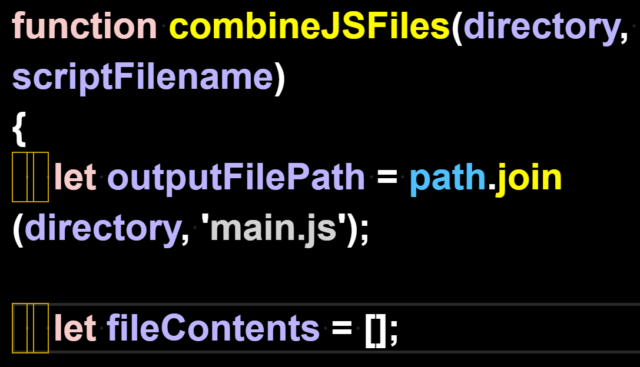

We can't leave those junk characters in the code, so we remove them with find/replace.

We Find 1 of the spaces.
We Replace All with the 1 space that we typed. This gets rid of the junk characters in the code.

We highlight 1 space with our mouse arrow:
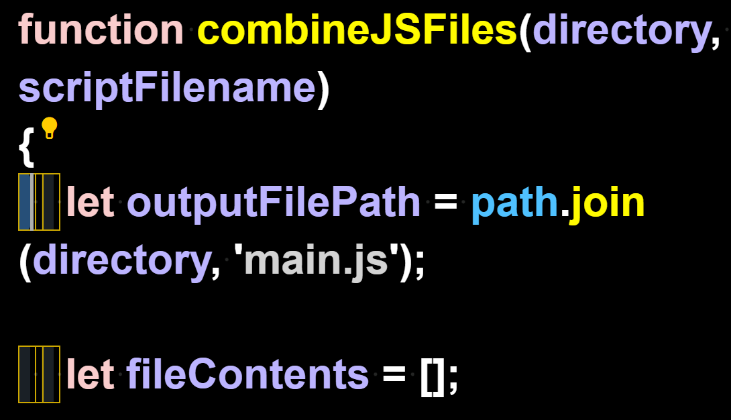
We press Control + H to open the Find/Replace feature and Replace All with our own Space
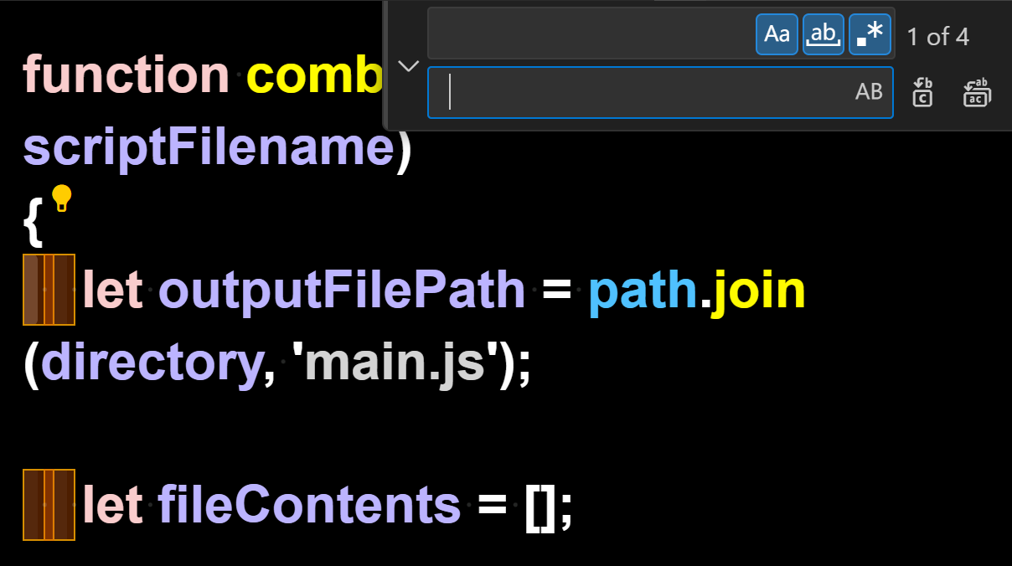

Here we see that the Find/Replace All has replaced the junk characters

with our working spaces instead:
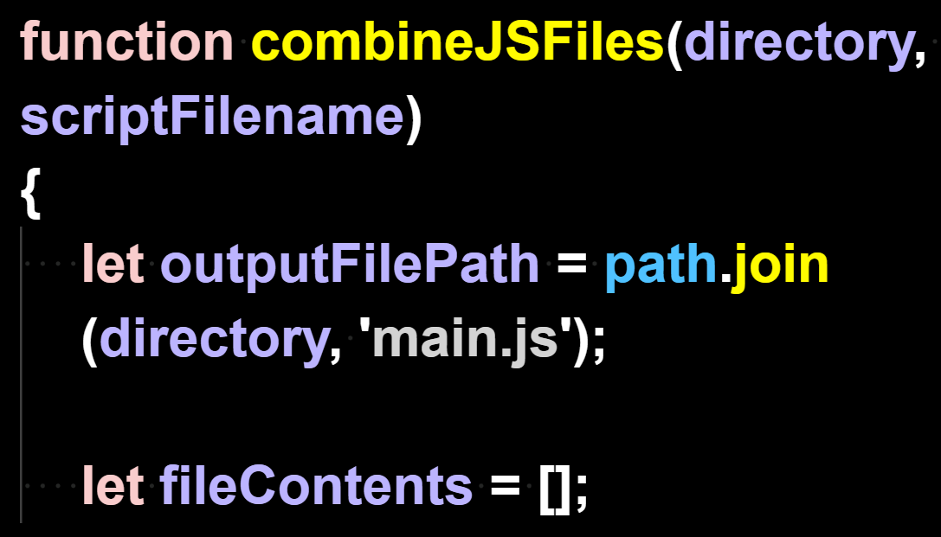

Now that the code
has no junk characters,
it can run.

True Artificial Intelligence System
Tautology
1111
Contra-
-diction
0000
XOR
0110
XNOR
1001
AND
0001
NAND
1110
OR
0111
NOR
1000
MI
1101
MNI
0010
LP
0011
LC
1100
RP
0101
RC
1010
CI
1011
CNI
0100
16-Gon
For More Tutorials:

GitHub.com/ChristopherTopalian
GitHub.com/ChristopherAndrewTopalian
Sites.google.com/view/CollegeOfScripting
CollegeOfScripting.weebly.com
CollegeOfScripting.wordpress.com
Youtube.com/ScriptingCollege
Twitter.com/CollegeOfScript
Rumble.com/user/CollegeOfScripting

Dedicated to God the Father

This book is created by the
College of Scripting Music & Science.
Always remember, that each time you write a script with a pencil and paper, it becomes imprinted so deeply in memory that the material and methods are learned extremely well.

When you Type the scripts, the same is true. The more you type and write out the scripts by keyboard or pencil and paper, the more you will learn programming!

Write and Type every example that you find.
Keep all of your scripts organized.
Every script that you create increases your programming abilities.
SEEING CODE, is one thing,
but WRITING CODE is another.
Write it, Type it, Speak it, See it, Dream it.

CollegeOfScripting.weebly.com

